PAC-Poly-NZ-Maori–Hei Tiki-Pounamu-Arahura Flower Jade



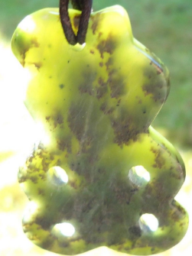 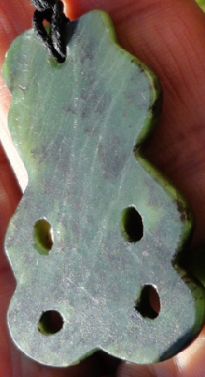

Figs. 1-4. PAC-Poly-NZ-Maori–Hei Tiki-Pounamu-Arahura Flower Jade

**Case no.: 22**

**Accession Number:**

**Formal Label:** PAC-Poly-NZ-Maori–Hei Tiki-Pounamu-Arahura Flower Jade

**Display Description:**

The hei-tiki ([/heɪˈtɪki/](https://en.wikipedia.org/wiki/Help:IPA/English))[[1]](https://en.wikipedia.org/wiki/Hei-tiki#cite_note-1) is an ornamental [pendant](https://en.wikipedia.org/wiki/Pendant) of the [Māori](https://en.wikipedia.org/wiki/M%C4%81ori_people) of [New Zealand](https://en.wikipedia.org/wiki/New_Zealand). Hei-tiki are usually made of [pounamu](https://en.wikipedia.org/wiki/Pounamu) ([greenstone](https://en.wikipedia.org/wiki/Nephrite_jade)), and are considered a [taonga](https://en.wikipedia.org/wiki/Taonga" \o "Taonga) (treasure) by Māori. They are commonly called [tiki](https://en.wikipedia.org/wiki/Tiki" \o "Tiki) by New Zealanders, a term that actually refers to large human figures carved in wood, and, also, to the small wooden carvings used to mark sacred places. (The word hei in [Māori](https://en.wikipedia.org/wiki/Maori_language) can mean "to wear around the neck".)

The development of sawing and carving of pounamu was associated with making of the classic style of pounamu adze blades by sawing off wedge and rectangular shapes, the blanks of which could also be used for carving hei tiki probably post-1500 (Groube 1967, 1969).

Mythologically, the origin of the hei-tiki comes from two pakiwaitara or ‘traditional stories.’

The first hei tiki origin story involves Ngahue, an ancestor god who fled from Hawaiki with his coveted pounamu fish, Poutini, fearing that goddess Hine-tua-hoanga would destroy his tiki with her abrasive cutting-stone, Whaiapu. After a long journey Ngahue and Poutini made landfall at Tuhua or ‘Mayor Island’ in the Bay of Plenty, but they soon sensed the arrival of their foe and continued onwards, arriving at length at the remote Arahura River on the South Island's West Coast. Here Ngahue deposited Poutini making this an eternal resting place for his precious stone. He then returned to Hawaiki with a portion of pounamu taken from the side of his fish. Back in Hawaiki Ngahue told the people of the richness of the large land he had discovered. Then he worked upon the pounamu of his fish to fashion the first hei tiki, kuru-pounamu ‘ear pendants’ and toki ‘adzes’. H used the toki to carve ocean voyaging canoes on which the people of Hawaiki then sailed to Aotearoa (Grey 1854: 68-69): “...i te hei-tiki etahi...” by the power of hei tiki they carried (1854:68). The narrative (English in Grey 1855b:82-84) has been attributed primarily to Te Rangikaheke, a principal chief of Ngāti Rangiwewehi, Te Arawa (Simmons 1966a:179).

A second hei tiki origin myth involves Hine-te-iwaiwa, the daughter of the god Tane (Orbell 1995:64) and sister of Māui. Tane gave his daughter her first hei tiki (Best 1914:131, Grey 1855a:50). Hine-te-iwaiwa married Irawaru, who was transformed into a dog by [Māui-tikitiki](https://en.wikipedia.org/wiki/M%C4%81ui_(M%C4%81ori_mythology)" \o "Māui (Māori mythology)). In her grief Hinauri threw herself into the sea and was cast ashore at Motutapu (sacred island) the home of Tinirau, where she attracts his attention by muddying the pools he uses for breeding fish (Grey 1855a:54,81). Tinirau is a guardian of fish, a son of [Tangaroa](https://en.wikipedia.org/wiki/Tangaroa" \o "Tangaroa), the god of the sea. Hine-te-iwaiwa and Tinirau slept together, and this angered Tinirau’s co-wives, Makai-atua-uriuri and Makai-atua-haehae. Hine-te-iwaiwa killed both by invoking a powerful karakia ‘incantation.’ Then she threw stones at them and as they struck Tinirau’s co-wives they burst and the discovery of greenstone or pounamu was revealed from which the first hei tiki were carved (Reed 2004:150).

Traditionally there were several types of hei-tiki which varied widely in form. Modern-day hei-tiki however, may be divided into two types. The first type is rather delicate, with a head/body ratio of approximately 30/70, with small details included, such as ears, elbows, and knees. The head is on a tilt, and one hand is placed on the thigh, and the other on the chest. The eyes are relatively small. The second type is generally heavier than the first. It has a 40/60 head/body ratio, both hands are on the thighs, and the eyes are proportionately larger.

From the size and style of traditional examples of hei-tiki it is likely that the stone was first cut in the form of a small adze. The tilted head of the pitau variety of hei-tiki derives from the properties of the stone - its hardness and great value make it important to minimise the amount of the stone that has to be removed. Creating a hei-tiki with traditional methods is a long, arduous process during which the stone is smoothed by abrasive rubbing; finally, using sticks and water, it is slowly shaped and the holes bored out. After laborious and lengthy polishing, the completed pendant is suspended by a plaited cord and secured by a loop and toggle.

**LC Classification:**

**Date or Time Horizon:**

**Geographical Area:**

**Map:**

**GPS coordinates:**

**Cultural Affiliation:**

**Medium:** Arahura Flower Jade

**Dimensions:** 50 mm long and 30 mm wide

**Weight:**

**Condition: original**

**Provenance:** Wellington, NZ

**Discussion:**

**Hei tiki were mad of wood a perishable material, which was recorded in** 1772 in Northland by Crozet who observed the wearing of wooden tiki figures in addition to the wearing of pounamu hei tiki (Ling Roth 1891:45): “in the middle of every village there is a carved figure which appears to represent the tutelary god of the village. In their houses are to be found similar figures like little idols placed in positions of honour. Several savages carried similar figures carved in jade or in wood around their necks. These figures are simply hideous; they nearly all have an immoderately long tongue and have a fearful look.” The classic Māori manaia, marakihau and pekapeka pendants are also pounamu renditions of similar distinctive imagery found in wood carving (Archey 1936:49, Neich 1997:18-21). The imagery of several pounamu pendants appear to have their origins in wood carving suggesting the plausibility of Archey’s argument for the development of hei tiki from earlier wooden prototypes.

Skinner constructed an evolutionary sequence for surviving stone, bone or shell hei tiki by making comparisons with tiki figures ranging in order of assumed stylistic antiquity from the human bone tiki pendants of the Marquesas Islands (Skinner 1932:207) and the wooden maoi miro figures from Rapanui ‘Easter Island’ (Skinner 1940:4,14-15), to the most common style of hei tiki. The lineage within Aotearoa extends from two painted rock art human figures from the South Island – one headless and one with an erect head – (Skinner 1916:311-312, Fig.1), to an archaic headless tiki pendant from Otago made of serpentine (1916:312, Fig.2, 313; Figure 1 below), to three pounamu anthropomorphic pendants from Otago with abbreviated limbs and all perforated with holes for suspension (1916:312 Fig.3, 313), to an attributed archaic style of pounamu hei tiki designated as variety A with erect upright head, suspension hole, and possibly abbreviated legs (1932:207,210,Plate A No.5; Figs 2 and 3), and finally to the most common style of pounamu hei tiki designated as variety B with head inclined to one side (1932:Plate A,207,208, Figure 4 below).

The morphological comparative technique employed by Skinner in constructing this sequence relied upon the identification of certain archaic features of style inherited from tropical Polynesia and the identification of some classic features resulting from local development within New Zealand. Archaic features include notching, abbreviated legs, forked tongue, the absence of a head, an upright head, and a hand positioned to the mouth. Classic features include the presence of holes for suspension, heads inclined to one side, and a general dissimilarity with anything archaic. Position within the sequence depended upon the extent to which these features were present. For example, the anthropomorphic pendants are positioned midway upon account of having abbreviated limbs (attributed archaic feature) and suspension holes (attributed classic feature). Since considerable unevenness exists throughout the various regions of New Zealand in the transition from the archaic to classic phases of Māori culture, Golson (1959), Davidson (1984:223) and Furey (1996:179) recognize that some archaic elements of material culture, including archaic style of personal adornments appear not to have transitioned into the classic phase at all in certain areas such as the Coromandel Peninsula. Hei tiki of similar age but from different localities possess some archaic features more so than others. The hei tiki with upright head, for example, may merely represent a style of hei tiki from localities in which that archaic trait, persisted longer than in other districts.

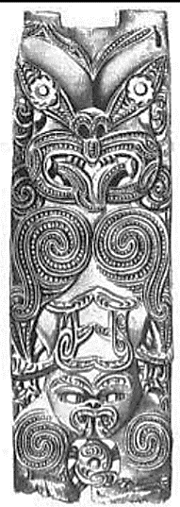

Fig. 5 An 18th century poupou carving collected from Tolaga Bay in 1769 by Cook; 1771 engraving by John Frederich Miller. In the collection of Tuebingen University, Germany (Wood 2012, pl. 7.25) shows the poupou in pre-restored state with the top end cut off; recorded as 980mm long by 330mm wide superseded by an image of the fully restored poupou (Schwabisches Tagblatt, 8. August 2013).

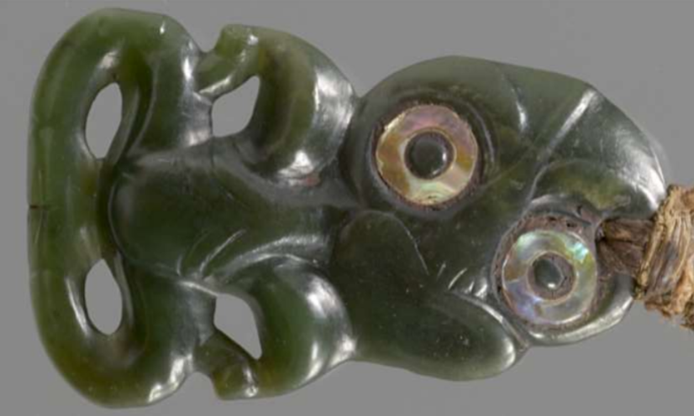

Fig. 6. Kunsthistorisches Museum 23, Vienna Ex Forster Collection; Second Cook voyage.

A small hei tiki with stylised features conforming relatively closely to a wedge shaped outline. The head is marginally peaked on top and tilts to the right at an approximate 45 degree angle. A forehead ridge extends to the nose-bridge but details of the nose-bridge and nose appear to be mostly worn away. Part of an arched nostril can be seen. Large eyes have inlay of un-serrated pāua shell and secondary rims around the upper margins. Resin inlay adhesive is visible. Prominent brows are evident with a hole drilled straight through the upper brow above the left eye. The mouth is heart shaped with inner details apparently worn away. A central ridge beneath the head forms an indicative neck which forks on the lower end to form two sets of ribs. The arms rest on the thighs. Elbows are pointed and lugged. No hands. Smoothly worn knobs are visible at the knees and at the ankles. Thighs and lower legs curve around in tapered fashion to meet at well-defined three toed feet. The finely plaited muka cord is of multiple strands and exhibits wear in places; bone toggle.

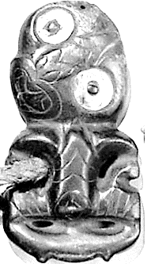

Fig. 7 An 18th century hei tiki. Hei tiki of the common Webster type I shape collected on one of Cook’s voyages to New Zealand 1769-1777. 100mm long. From The Field Museum, Chicago; collection number 273856. Image, Field Museum, A97305

100 mm (length) x 52 mm (width); Wear assessed as 2 out of 10 The features of this hei tiki conform to a predominantly rectangular outline shape with a slight wedge aspect to it. The head is rounded marginally on top and tilts to the left at an approximate 45 degree angle, although the centre of the face does not align well with the lower pointed lip. Two large eyes have wide rings of un-notched pāua shell inlay. Brows are indistinct / absent. The forehead ridge forks at the nose-bridge. Well defined arched nostrils. A heart shaped mouth has four teeth with an internal tongue splayed against the left corner tooth. The direction of the tongue towards the inner part of the hei tiki is uncommon. An indicative neck forks on the lower end to form ribs: two per side. Grooves of the large diamond shaped vagina are of similar proportion to those of the ribs. Both arms are positioned downwards with three fingered hands rendered upon the thighs, possibly in raised relief. The thighs extend straight outwards to cornered knees. The lower legs have prominent ankle projections; no feet. Leg and arm cavities are worked through in economical fashion. A thick plaited cord is attached through the right arm cavity in apparent non-original fashion. Bird wing bone toggle has grooved diagonal patterns. The cord appears to be somewhat worn in places. The end of the suspension hole can be seen above the right eye. The small size of the hole indicates it has been drilled mostly from the back; although the top surface is rough indicating possible loss to the original surface and top part of the hole. Ex A.W.F. Fuller Collection; Ex Leverian Museum, London (Kaeppler 1978:177).

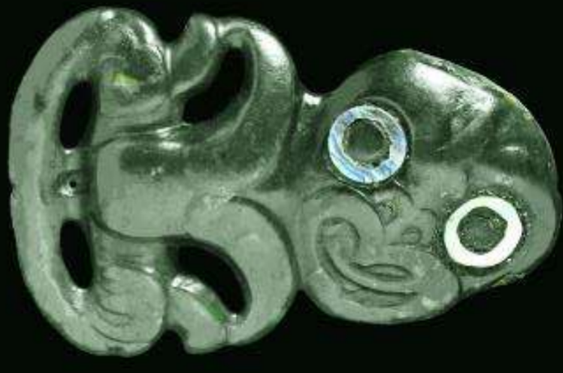

Fig. 8. Pitt Rivers Museum 1886.1.1167, Oxford Ex Forster Collection; Second Cook voyage

100 mm (length) x 63 mm (width); Wear assessed as 2 out of 10 The features of this hei tiki appear to have been worked substantially away from the confines of the original piece of pounamu, a characteristic also evident in the rendering of the extensive inner arm and leg cavities. The head is slightly rounded on top and tilts to the hei tiki’s right at an approximate 45 degree angle. A worn forehead ridge forks at the nose bridge; prominent arched nostrils to the nose. The large eyes are inlaid with thin rings of un notched pāua shell. A prominent brow is evident above the left eye. The heart-shaped mouth has small teeth in the right corner and at the bottom middle. A tongue extends to the left side of mouth, and possibly originally beyond, but details are not visible, possibly worn. A slightly extended neck is evident on the right hand side, but on the left side the head rests directly upon the shoulder. The upper arms are unusually narrow directly above the elbows and they join to the chest in distinctive fashion. No ribs. The lower arms are exceptionally wide. Also distinctive are the three fingered hands carved onto the thighs in raised relief. Thighs extend straight outwards to rounded knees. Lower legs taper together with feet delineated by a lower notch and a small hole drilled above. Worn knobs are visible at the knees.

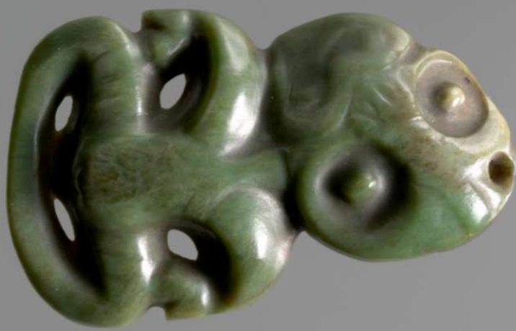

Fig. 9. Kunsthistorisches Museum 22, Vienna Ex Forster Collection; Second Cook voyage.

85mm x 55mm; Wear assessed as 8 out of 10 This Hei tiki has a slightly elongated head which tilts to the left at an approximate 45 degree angle. The fore head ridge forks at the nose-bridge; prominent arched nostrils; large, deeply grooved eyes without inlay; indistinct brows. Heart shaped mouth with worn teeth in corners. Indicative neck forks on the lower end to form ribs: one per side. Lower arms bend inwards at downturned sharply pointed elbows. Three fingered grooved hands on the thighs. Female sex indicated. Thighs extend outwards to rounded knees. Lower legs taper and join together. No feet. Work to the arm and leg cavities is relatively extensive, possibly due to deep thickness of hei tiki; wide thighs and upper arms. Pounamu is of pale inanga variety. The features are worn significantly possibly resulting in loss of original eye inlay.

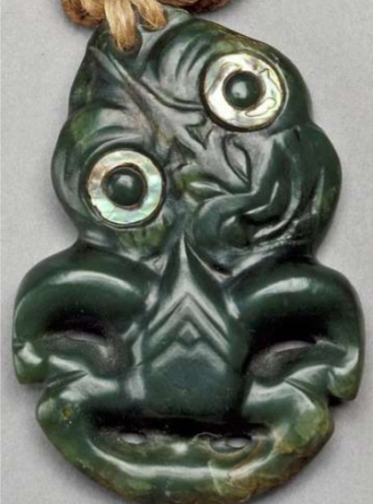

Fig. 10. The Royal Collection Trust, London, RCIN 69263

70mm (l) x 50mm (w) x 10mm (d); Wear assessed as 1 out of 10 Given to King George III by Captain James Cook A relatively small hei tiki with features highly stylised to conform within an oval-like outline shape. Enlarged upper arms contrast with reduced legs. The top of the head is accentuated into a peak and is notable for having two suspension holes. The head tilts to the right at an approximate 45 degree angle. The forehead ridge forks at the nose bridge. The lower nose is flared in distinctive alternative fashion and joins with the nose bridge via a central ridge. The large eyes are inlaid with un-notched rings of pāua shell. Secondary eye rims and prominent brows are in evidence above the eyes. The heart shaped mouth has three teeth and an extended forked tongue, the details of which may have worn somewhat. Head rests directly upon the shoulders. A sharply pointed central ridge beneath the head forms an indicative neck which forks on the lower end to form ribs: two per side. A small diamond shape is worked beneath the fork of the ribs. Arms curve outwards and then inwards to rest on the thighs in conventional Webster type 1 fashion. Elbows are pointed. No hands or feet. Hei tiki is made from a pale coloured pounamu of inanga variety. Plaited cord with bone toggle on the end. Hei tiki is widest at the mid-point. (Kaeppler 1978:177, Fig.332).

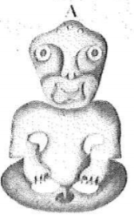 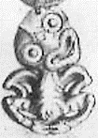

Fig. 11. Hei tiki from Doubtless Bay. While essentially configured in symmetrical type I style, this hei tiki also contains some Webster type II elements of design in terms of its relatively narrow head, small eyes, absence of both a brow ridge and absence of an indicative neck. It is accordingly identified as type I/II. In addition to its upright head the hei tiki is notable for being fully symmetrical and apparently having two suspension holes. Outline shape is identified as shape A.

Fig. 12. Hei tiki from Mahia Peninsula. Of style type I with large eyes, head resting directly upon the shoulders, and both arms positioned to the thighs. It also has a forked extended tongue and two sets of ribs; female sex. Outline shape is tentatively identified as shape D.

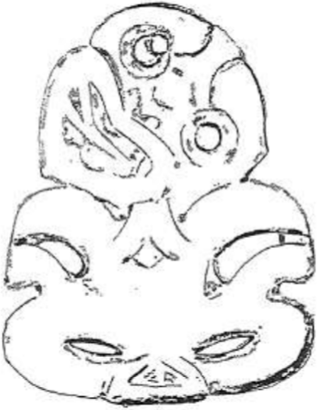

**Fig. 13.** The Burr hei tiki is of type I. Features of note include the forked tongue, the diamond shape beneath a set of forked ribs, and the small head projections at the chin and at the left ear. The suspension hole is drilled through the upper eye. The outline most closely resembles shape B.

The British Museum. Tiki belonging to Captain Cook. Trustees of the British Museum. [Accessed 5 December 2013]. Available from: http://www.britishmuseum.org/explore/highlights/highlight_objects/loan_in/t/tiki_belongi ng_to_captain_cook.aspx Unpublished sources: Belcher, P., 2005. Hei Tiki. Eastern Institute of Technology, Hawkes Bay Te Papa collection accession record, 1912. Acquisition – Donation; Lord St Oswald.

**Type 2**

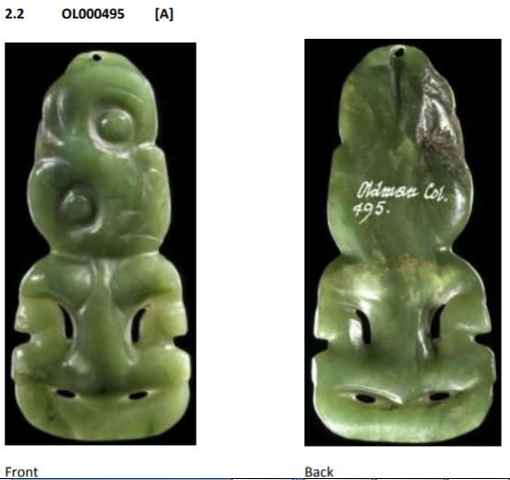 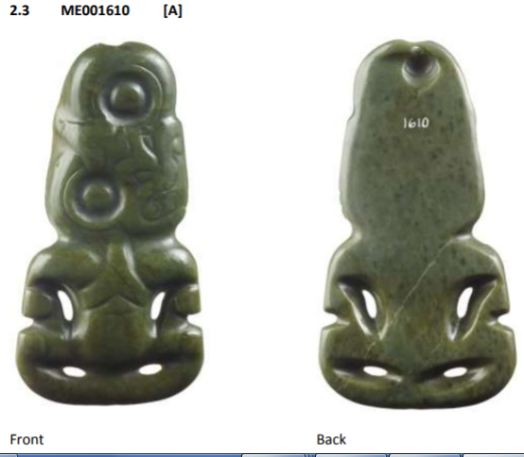

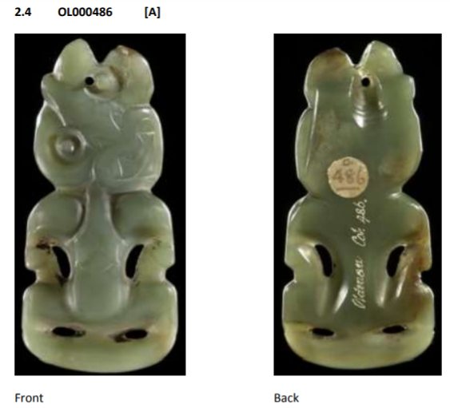 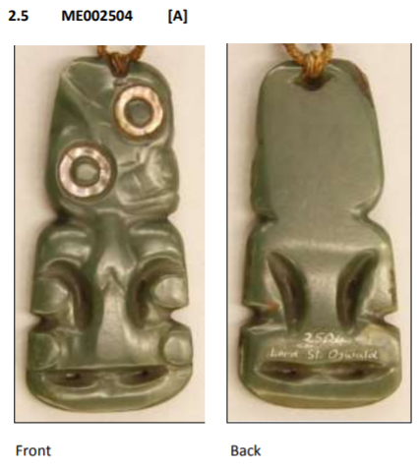 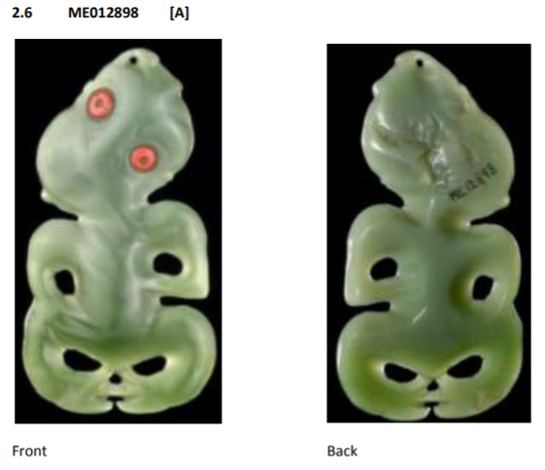 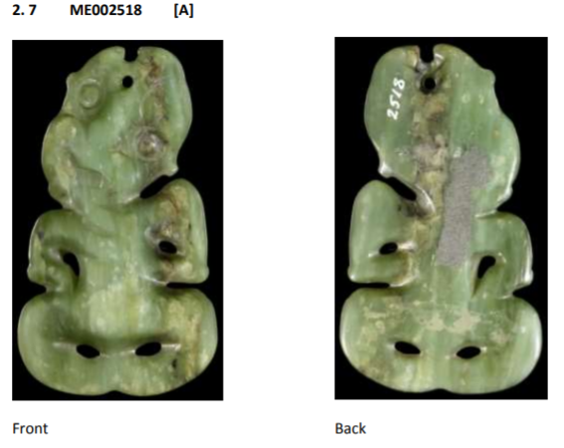 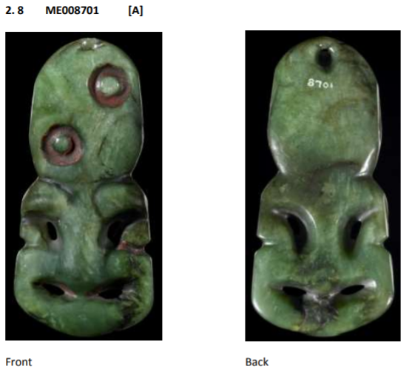 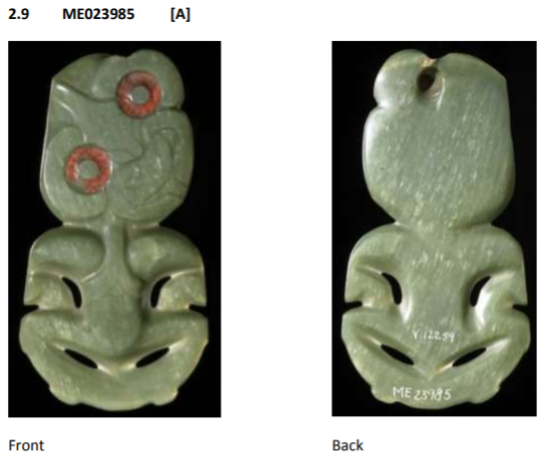 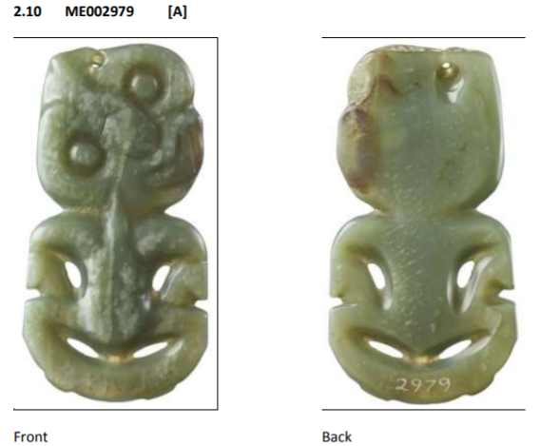 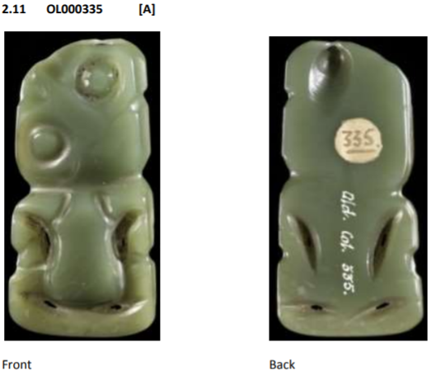 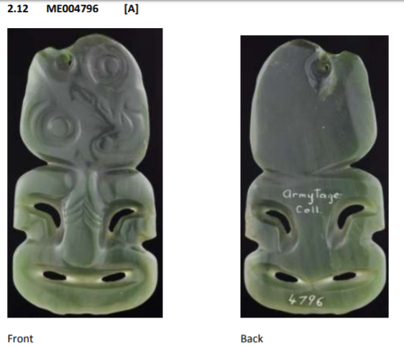 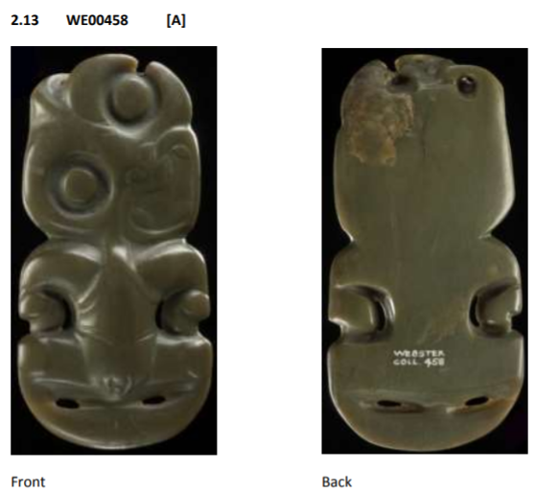 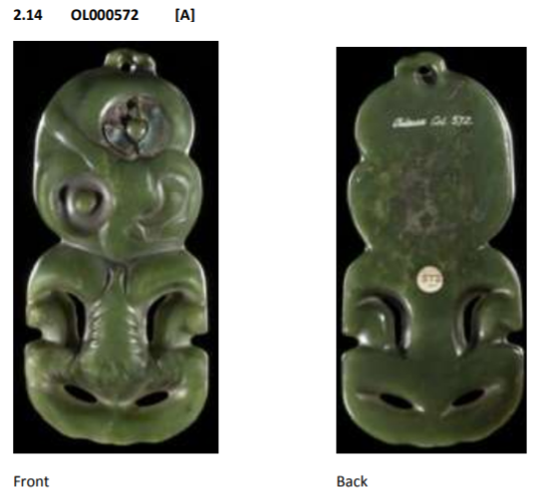 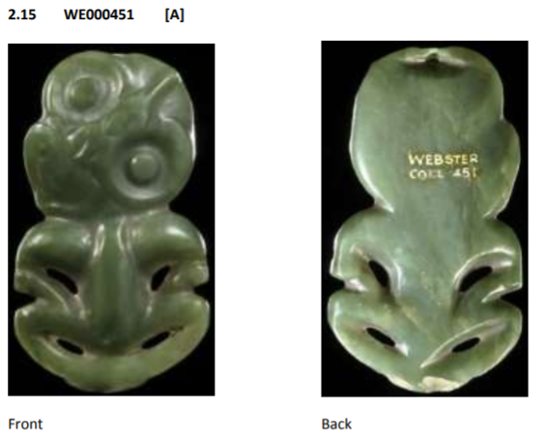 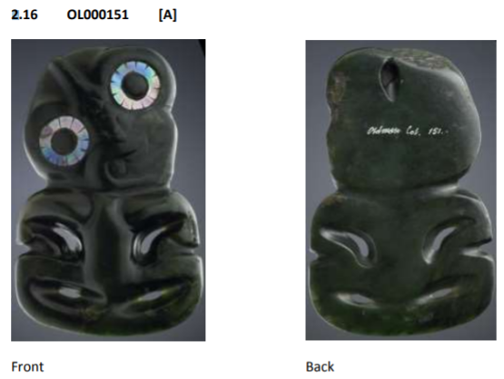 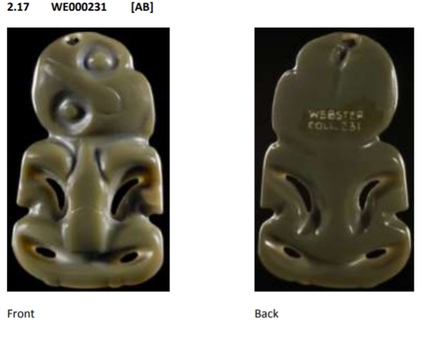 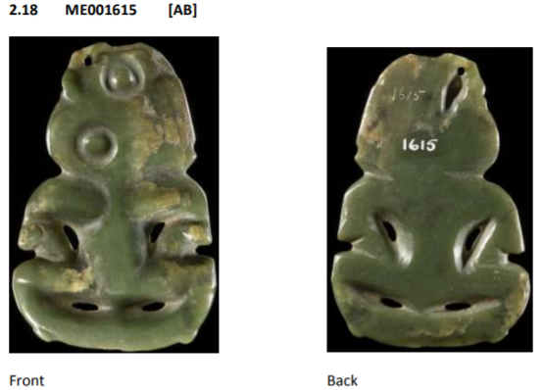

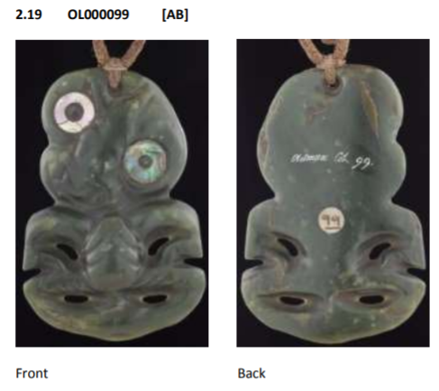 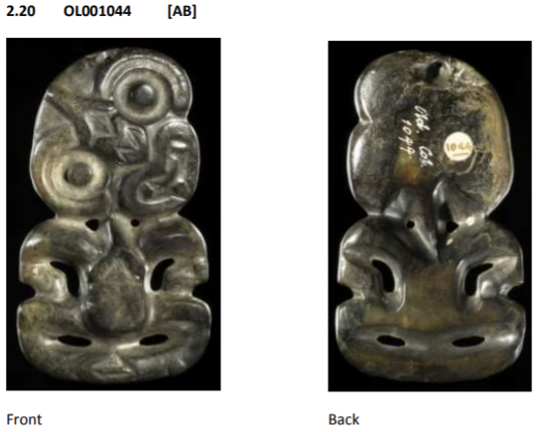

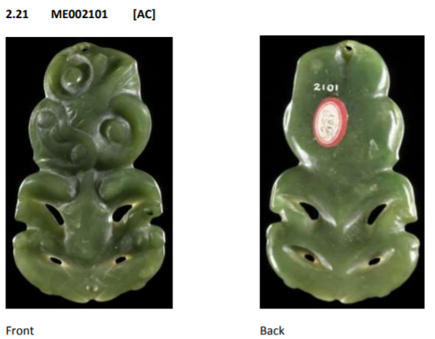 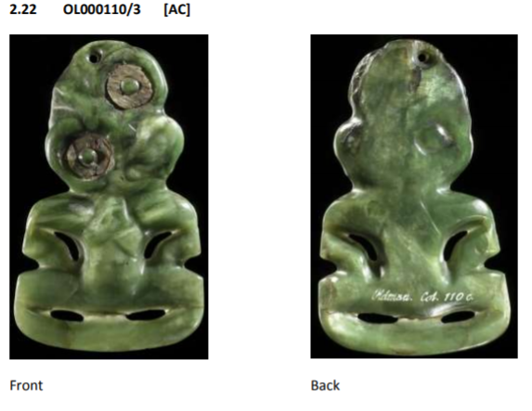 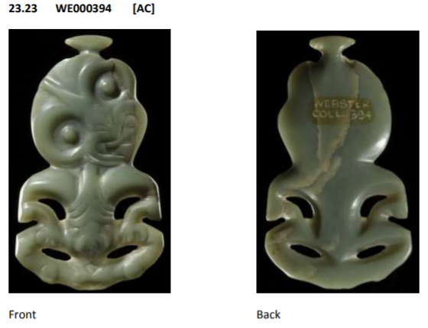 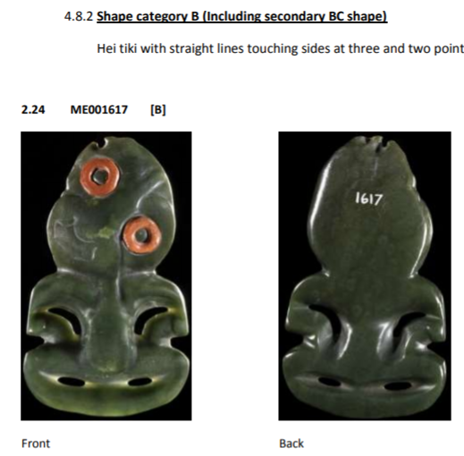 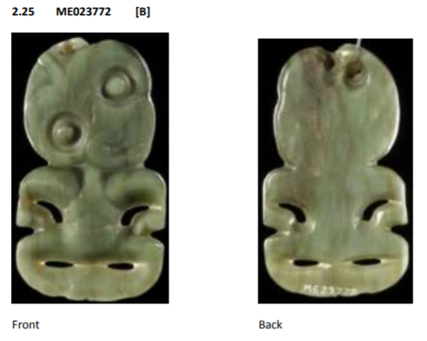 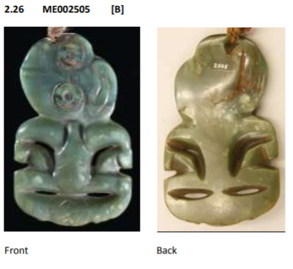 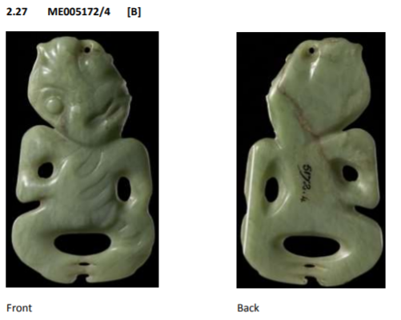 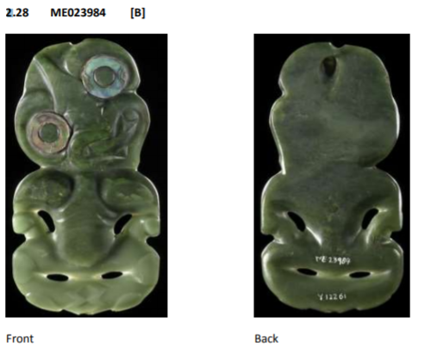 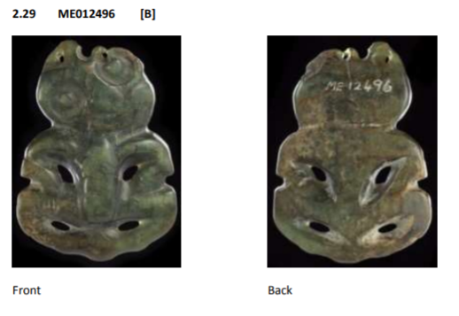 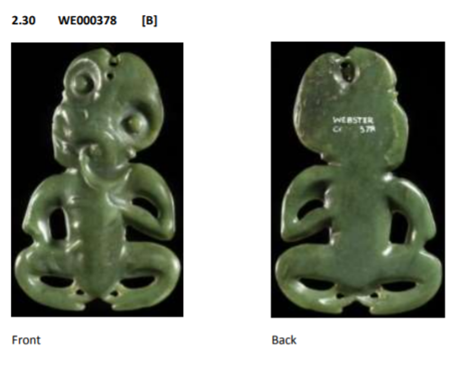 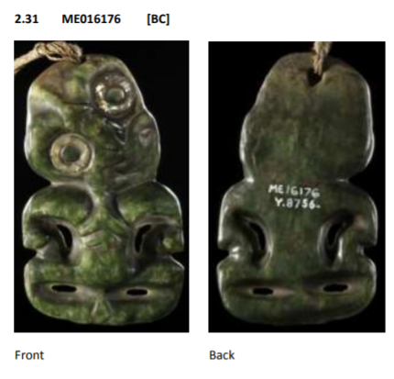  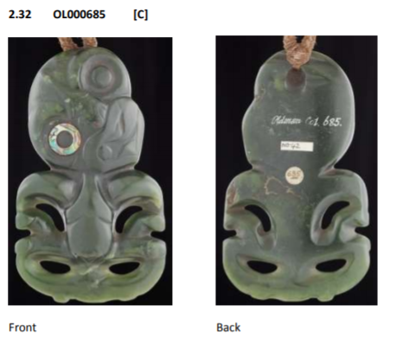 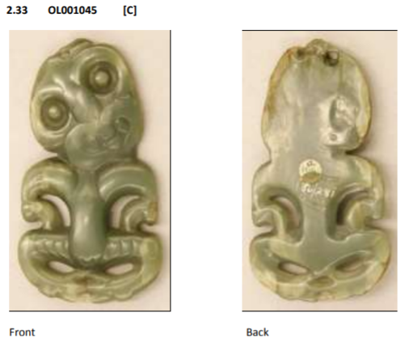v 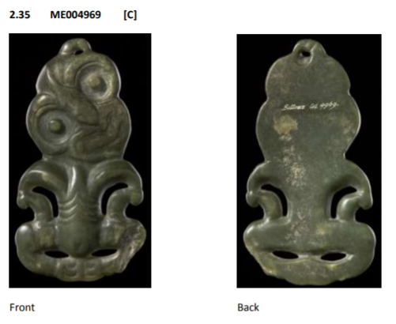 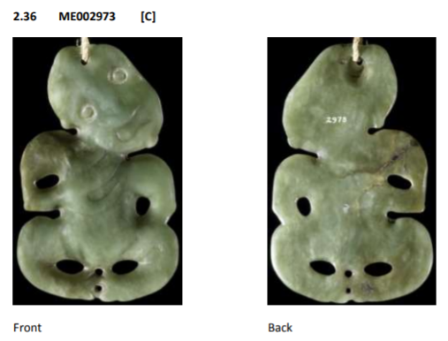 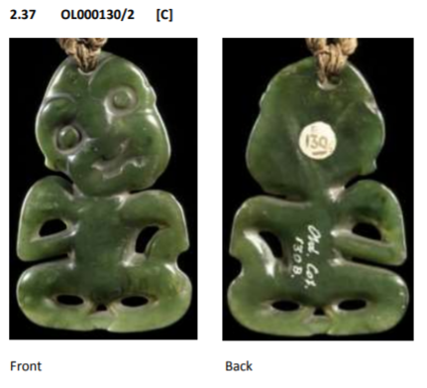 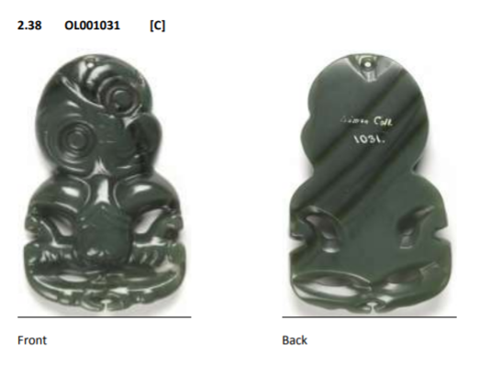 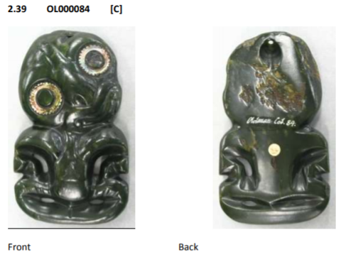 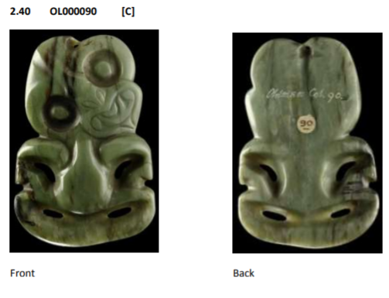 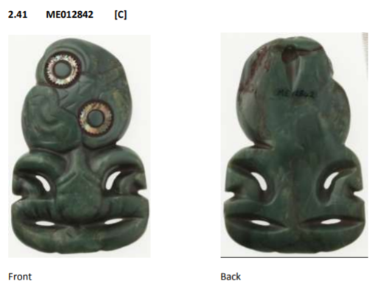 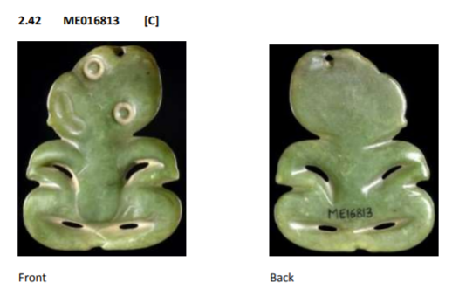 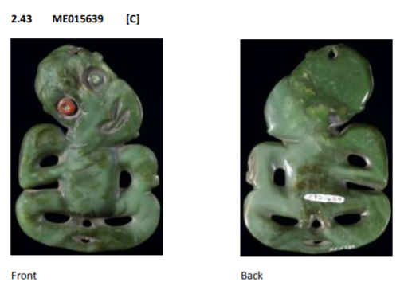 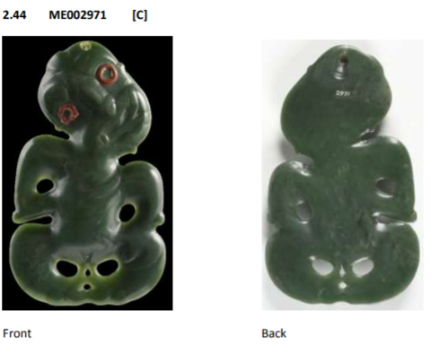 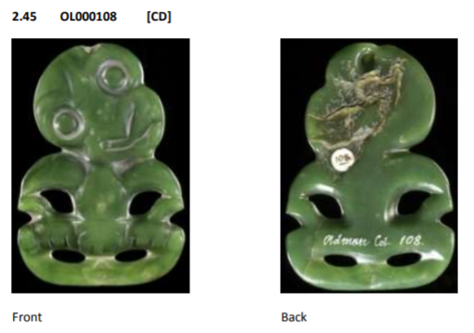 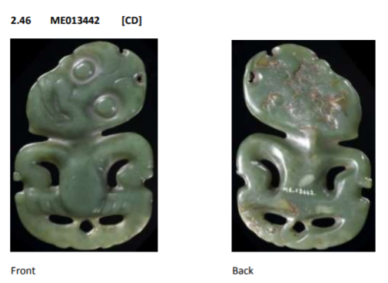 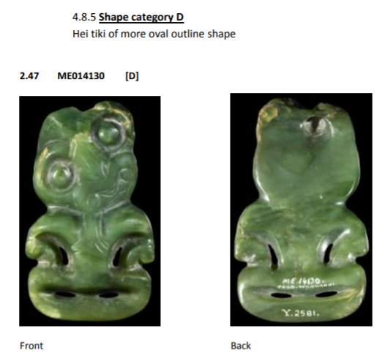 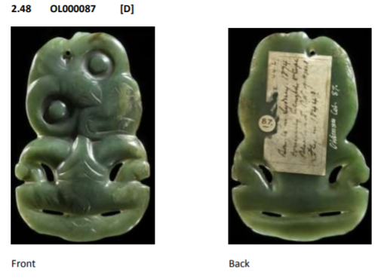 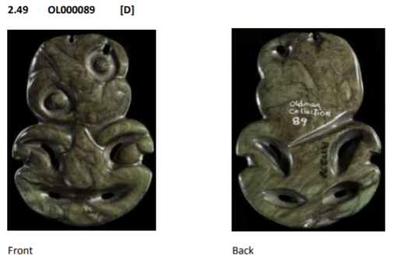 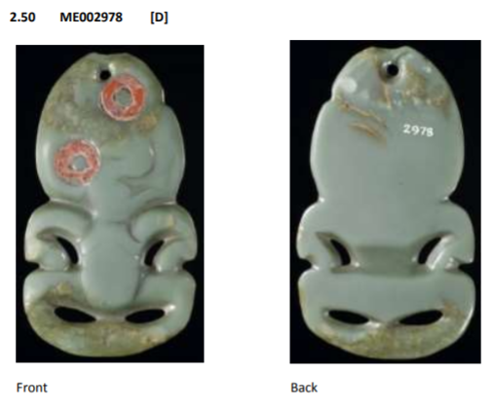

**References:**

**Museums**

Field Museum, Chicago

Kunsthistorisches Museum, Vienna

Pitt Rivers Museum, Oxford

Royal Collection Trust, London

**Books, Articles**

Anderson, A., 1998. The Welcome of Strangers: An ethnohistory of southern Maori A.D.1650-

1850: University of Otago Press.

Anderson, A., 2008. A Migration History. In Te Maire Tau and Atholl Anderson (eds), Ngāi

Tahu: A Migration History: The Carrington Text. Wellington: Bridget Williams Books in

association with Te Rūnanga O Ngāi Tahu, pp.20-37.

Archey, G., 1933. Evolution of Certain Maori Carving Patterns. Journal of the Polynesian

Society, 42:171-190.

Archey, G., 1936. Maori Carving-Patterns. Journal of the Polynesian Society, 45:49-62.

Barrow, T., 1961. Two hei tiki-matau Amulets. Journal of the Polynesian Society, 70:353.

Barrow, T., 1962. An Experiment in Working Nephrite. Journal of the Polynesian Society,

71:254.

Barrow, T., 1964. The Decorative Arts of the New Zealand Maori. Wellington and Auckland:

Reed.

Beattie, H., 1994. Traditional Lifeways Of The Southern Maori: the Otago University Museum

ethnological project, 1920. A. Anderson (ed.), Dunedin: University of Otago Press in

association with Otago Museum.

Beck, R.J., with Maika Mason, 2002. Mana Pounamu: New Zealand Jade. Birkenhead,

Auckland: Reed Publishing (NZ) Ltd.

Beck, R.J., with Maika Mason, 2010. Pounamu: the jade of New Zealand. North Shore,

Auckland: Penguin Group (NZ).

Best, E., 1912. The Stone Implements of the Maori. Wellington: Dominion Museum Bulletin,

No. 4, 1912.

Best, E., 1914. Ceremonial Performances Pertaining To Birth, As Performed By The Maori Of

New Zealand In Past Times. The Journal of the Royal Anthropological Institute, 154:127-131.

Best, E., 1924. The Maori As He Was. Wellington: Government Printer.

Brown, D., 2003. Tai Tokerau Whakairo Rākau: Northland Māori Wood Carving. Birkenhead,

Auckland: Reed Publishing (NZ) Ltd.

Chapman, F.R., 1891. On the Working of Greenstone or Nephrite by the Maoris.

Transactions of the New Zealand Institute, 24:479-539.

Day, K., 2001. Māori Wood Carving of the Taranaki Region. Birkenhead, Auckland: Reed

Publishing (NZ) Ltd.

Davidson, J., 1984. The Prehistory of New Zealand. Auckland: Longman Paul Limited.

Davidson, J., 1996. Maori Prehistory. In Starzecka (ed.), 1996. pp.8-25.

Edge-Partington, J., 1996. In B.L. Miller (ed.), Ethnographical album of the Pacific islands.

Bangkok: SDI Publications. 2nd edn.

Furey, L., 1996. Oruarangi: The archaeology and material culture of a Hauraki pa. Bulletin Of

The Auckland Institute And Museum, No. 17, 1996.

Gell, A., 1998. Art And Agency: An Anthropological Theory. Oxford: Clarendon Press.

Grey, George, 1854. Ko Nga Mahinga A Nga Tupuna Maori. London: George Willis.

Grey, George, 1855a. Polynesian Mythology And Ancient Traditional History Of The New

Zealand Race. Albemarle Street, London: John Murray. 1

st edn.

Grey, George, 1885b. Polynesian Mythology And Ancient Traditional History Of The New

Zealand Race. Auckland: H. Brett, Evening Star Office. 2

nd edn.

Golson, J., 1959. Culture Change in Prehistoric New Zealand. In J.D. Freeman and W.R.

Geddes (eds), Anthropology in the South Seas. New Plymouth: Avery, 29-74.

Groube, L.M., 1967. A Note On The Hei-Tiki. Journal of the Polynesian Society, 76:453-458.

Groube, L.M., 1969. From Archaic To Classic Maori. Auckland Student Geographer, 6:1-11.

Hakiwai, A., 1996. Maori Society Today. In Starzecka (ed.), 1996. pp.50-68.

Hawkesworth, J., 1775. An Account of the Voyages undertaken by the order of His Present

Majesty, for making Discoveries in the Southern Hemisphere, and successively performed by

Commodore Byron, Captain Wallis, Captain Carteret, and Captain Cook, in the Dolphin, the Swallow, and the Endeavour: Drawn from the Journals which were kept by the several

Commanders, and from the Papers of Joseph Banks, Esq. Vol.2, Dublin: James Williams.

Heaphy, C., 1904. A Visit to the Greenstone Country. Part II. In New Zealand Illustrated

Magazine. 1 November 1904, Auckland: p.97.

Hiroa, Te Rangi, 1950. The Coming of the Maori. Wellington: Whitcombe & Tombs. 2

nd edn.

Irwin, G., 2004. Kohika, The Archaeology Of A Late Maori Lake Village In The Ngati Awa Rohe

Bay Of Plenty New Zealand. Auckland: Auckland University Press.

Jacob, C., R. Walter and C. Jennings, 2010. Review Of The Archaeology Of Foveaux Strait,

New Zealand. Journal of the Polynesian Society, 119:25-59.

Kaeppler, A.L., 1978. “Artificial Curiosities”: being An Exposition of Native Manufacturers

Collected on the Three Pacific Voyages of Captain James Cook, R.N. Honolulu, Hawaii: Bishop

Museum Press.

Kaeppler, A.L., 2011. Holophusicon The Leverian Museum. An Eighteenth Century English

Institution of Science, Curiosity, and Art. Altenstadt, Germany: ZKF Publishers.

Kidwell, C.S., and Velie, A., 2005. Native American Studies. United Kingdom: Edinburgh

University Press.

Ling Roth, H., 1891. Crozet’s Voyage to Tasmania, New Zealand and the Ladrone Islands, and

the Philippines in the Years 1771-1772. Oxford Street, London: Truslove & Shirley.

Lockerbie, Leslie, 1959. From Moa-Hunter to Classic Maori in Southern New Zealand. In J.D.

Freeman and W.R. Geddes (eds), Anthropology in the South Seas. New Plymouth: Avery, 90-

93.

Makereti, 1986. The old-time Maori. Auckland: New Women’s Press.

Mallon, S., 2010. Against Tradition. In T. Wesley-Smith (ed.), The Contemporary Pacific.

Honolulu: University of Hawai’i Press, 22 (2):362-381.

Mataira, K., 1983. Negative and Positive Influences in the Development of Oceanic Art. In S.

Mead and B. Kernot (eds), Art and Artists of Oceania. Palmerston North: The Dunmore

Press, 80-87.

Mead, S.M., 1984. Nga Timatanga Me Nga Paringa O Te Mana Maori The Ebb and Flow of

Mana Maori and the Changing Context of Maori Art. In S.M. Mead (ed.), Te Maori: Maori Art

from New Zealand Collections. Auckland: Heinemann Publishers (NZ) Ltd, 20-36.

Mead, H.M., 2003. Tikanga Māori Living by Māori Values. Wellington: Huia Publishers.

Milligan, R.R.D., 1958. Ranginui, Captive Chief of Doubtless Bay, 1769. Journal of the

Polynesian Society, 67:194, Plates 1 & 2.

Neich, R., 1997. Pounamu: Maori Jade Of New Zealand. Auckland: David Bateman Ltd.

Oldman, W.O., et al, 2004. The Oldman Collection of Maori Artifacts. New Edition of

Polynesian Society Memoir 14.

Orbell, M., 1995. The Illustrated Encyclopedia Of Maori Myth and Legend. Christchurch:

Canterbury University Press.

Orchiston, D.W., 1972a. Maori Neck and Ear ornaments of the 1770's: a Study in

Protohistoric Ethno-Archaeology. Journal of the Royal Society of New Zealand, 2 (1):91-107.

Orchiston, D.W., 1972b. Maori greenstone pendants in the Australian Museum, Sydney. In

Records of the Australian Museum, 28:pp.161-213.

Phillips, W.J., 1966. Maori Life and Custom. Wellington: Reed.

Polack, J.S., 1838. New Zealand: Being a Narrative of Travels and Adventures During a

Residence in that Country Between the Years 1831 and 1837. Vol.1. New Burlington Street,

London: Richard Bentley.

Prickett, N., 1999. Nga Tohu Tawhito: Early Maori Ornaments. Albany, Auckland: David

Bateman Ltd.

Reed, A.W., 2004. Reed Book of Māori Mythology. Auckland: Reed Publishing (NZ) Ltd.

Robley, H.G., 1915. Pounamu, Notes on New Zealand Greenstone. London: T.J.S. Guildford &

Co. Ltd.

Salmond, A., 1991. Two worlds: first meetings between Maori and Europeans, 1642 –1772.

Auckland: Viking.

Salmond, A., 1997. Between worlds: early exchanges between Maori and Europeans, 1773 –

1815. Auckland: Penguin Books (NZ) Ltd.

Savage, John, 1807. Some Account of New Zealand. London: Union Printing Office.

Simmons, D.R., 1965. Perspectives in Maori Carving. In Landfall, 19 (2):pp.143-148.

Simmons, D.R., 1966a. The Sources Of Sir George Grey's Nga Mahi A Nga Tupuna. Journal of

the Polynesian Society, 75 (2):177-188.

Simmons, D.R., 1966b. Appendix Other Tiki In Otago Museum. In Skinner, H.D., 1966, The

Maori Hei-Tiki. Otago Museum Trust Board. 2

nd edn. Dunedin: pp.16-29.

Skinner, H.D., 1916. Evolution In Maori Art. – Pendants. Journal of the Royal Anthropological

Institute, 46:309-321.

Skinner, H.D., 1932. Maori Amulets In Stone, Bone, And Shell. Journal of the Polynesian

Society, 41:202-211.

Skinner, H.D., 1933. The Making of Mere-pounamu and Hei-tiki. Journal of the Polynesian

Society, 42:31.

Skinner, H.D., 1935. Maori Amulets in Stone, Bone, and Shell. Journal of the Polynesian

Society, 44:19-22.

Skinner, H.D., 1940. The Maori Hei-Tiki. Dunedin: Coulls Somerville Wilkie Ltd. 1st edn.

Skinner, H.D., 1959. Murdering Beach Collecting and Excavating, The First Phase: 1850 –

1950. Journal of the Polynesian Society, 68:219-238.

Skinner, H.D., with D.R. Simmons, 1966. The Maori Hei-Tiki. Dunedin: Otago Museum Trust

Board. 2nd edn.

Skinner, H.D., 1974. Comparatively Speaking: Studies in Pacific Material Culture 1921 –

1972. Dunedin: University of Otago Press.

Smith, L.T., 1999. Decolonizing Methodologies: Research and Indigenous Peoples. London:

Zed Books.

Starzecka, D.C. (ed.), 1996. Maori Art And Culture. London: British Museum Press.

Tamarapa, A., 2002. Anaru Rondon in conversation with Awhina Tamarapa. In H. Smith (ed.),

Taiāwhio Conversations With Contemporary Māori Artists. Wellington: Te Papa Press,

pp.154-165.

Te Awekotuku, N., 1996. Maori: People and Culture. In Starzecka (ed.), 1996. pp.26-49.

Thacker, M., 1960. Excavations at Pa Bay, Banks Peninsula. New Zealand Archaeological

Association Newsletter, 4 (1):8-12.

Trotter, M., and B. McCulloch, 1971. Prehistoric Rock Art Of New Zealand. Wellington: A.H.

& A.W. Reed Ltd.

Webster, K.A., 1948. The Armytage collection of Maori jade. London: Cable Press.

Wilkes, C., 1845. Narrative Of The United States Exploring Expedition. During The Years

1838, 1839, 1840, 1841, 1842. Vol.1, London: Wiley and Putnam.

Wood, P., 2012. Oceanic art and ‘curiosity’. In E. Barker (ed.), Art & Visual Culture 1600-

1850. London: Tate Publishing in association with The Open University, plate 7.25.

**Theses:**

Groube, L.M., 1964. Settlement Patterns in Prehistoric New Zealand. Unpublished M.A.

thesis, Anthropology, University of Auckland.

Jahnke, R.H.G., 2006. He Tataitanga Ahua Toi, the house that Riwai built / a continuum of

Maori art. Ph.D. thesis, Palmerston North: Massey University.

Price, L.K., 1994. H.D. Skinner as teacher: defining the paradigms in his teaching at the

University of Otago 1919-1952. Unpublished M.A. thesis, Anthropology, University of Otago.